COMMUNICATIONS UPDATE
communicate@blackburn.anglican.org
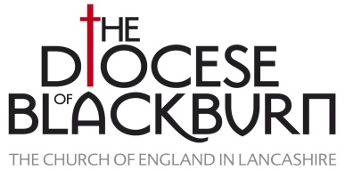

SPECIAL EDITION: Bishops’ Easter Messages
Bishop Julian, Bishop Geoff and Bishop Philip have issued their Easter messages for 2017.
In his message, Bishop Julian reflects on the recent attack on Coptic Christians in Egypt on Palm Sunday while Bishop Geoff recounts the amazing story of the Lampedusa Cross which makes invisible migrants visible in a unique way around the world. Meanwhile, Bishop Philip talks about the new beginning available to anyone who comes to know Jesus as their friend.
You can read all three messages here on the Diocesan website where each message can also be downloaded as a Word document.
All three messages are also available in video format on the Diocesan YouTube channel:
- Click here for the YouTube version of Bishop Julian’s message
- Click here for the YouTube version of Bishop Geoff’s message
- Click here for the YouTube version of Bishop Philip’s message
You are encouraged to play the videos in your parishes across the Easter weekend and share the links online with your family and friends. Please also remember to subscribe to our YouTube channel for ongoing notifications of the latest video uploads.
If you want to play the videos but your church doesn’t have wi-fi then click on this Dropbox link …
https://www.dropbox.com/sh/q08qkxmfl1rsrle/AABQrBeEHuan3o0hsSeUTTsha?dl=0
… which will allow you to download the original videos for playing offline.
Have a very happy and peaceful Easter.
Ronnie Semley, Diocesan Communications Manager

